**DEP TASK 4**

**Solving Error Occurring on Different Browsers**

**CHROME ERROR**

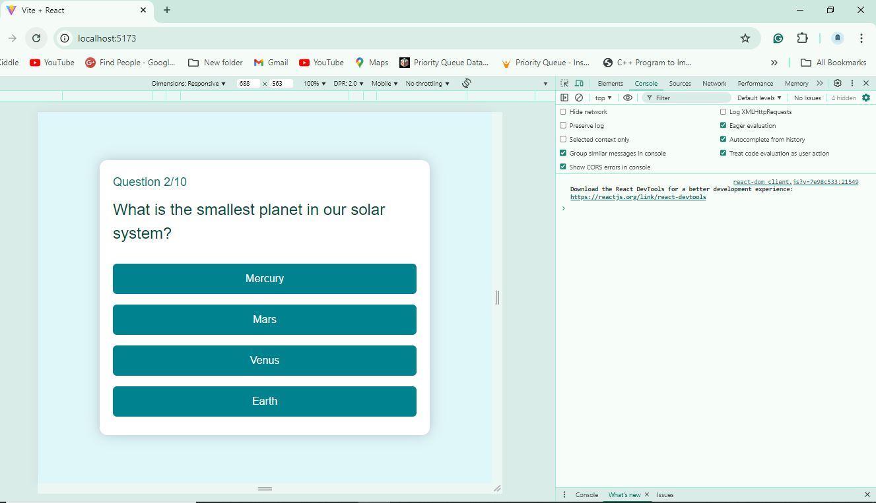

**No Errors and compatibility issue**

**Edge Error**

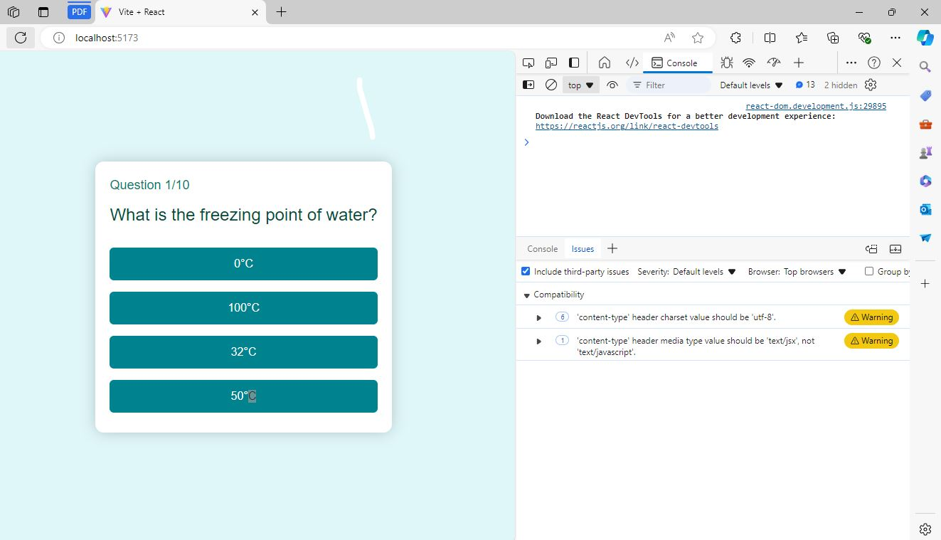

Content-Type: text/javascript 'content-type' header media type value should be 'text/jsx', not 'text/javascript'. Issues were occurring.

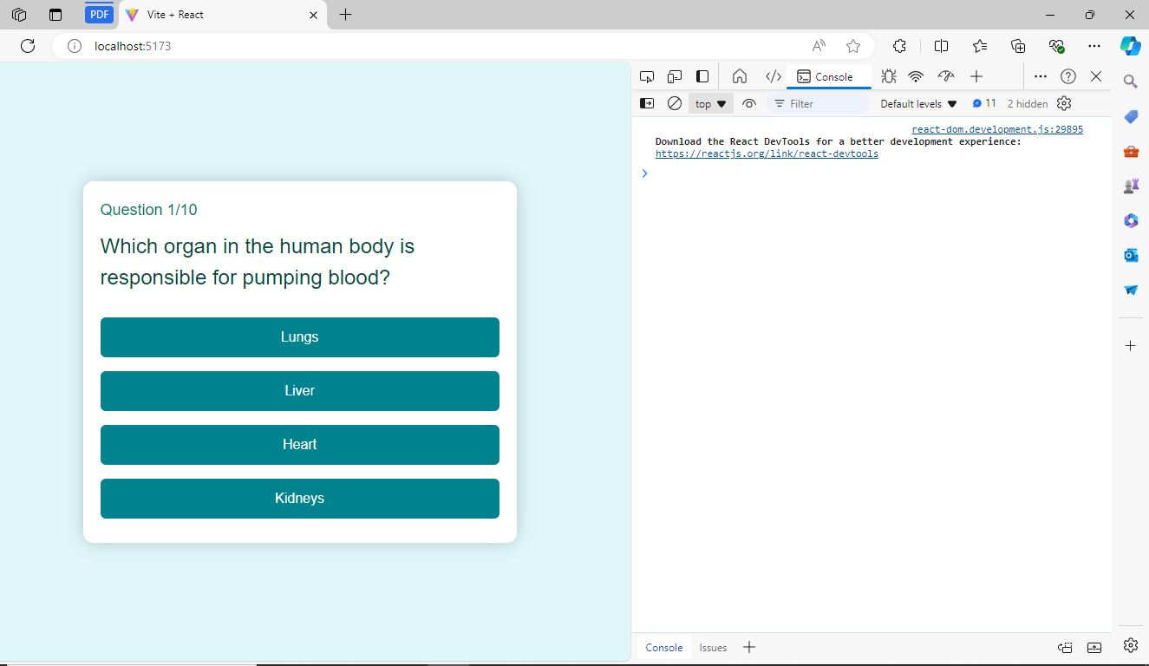

<script type="text/jsx" src="app.jsx"></script>

<script type="text/javascript" src="app.js"></script>

Added these two commands in HTML File for Edge Compatibility.

**FIREFOX ERROR**

No Compatibility Errors in Firfox Occurred

